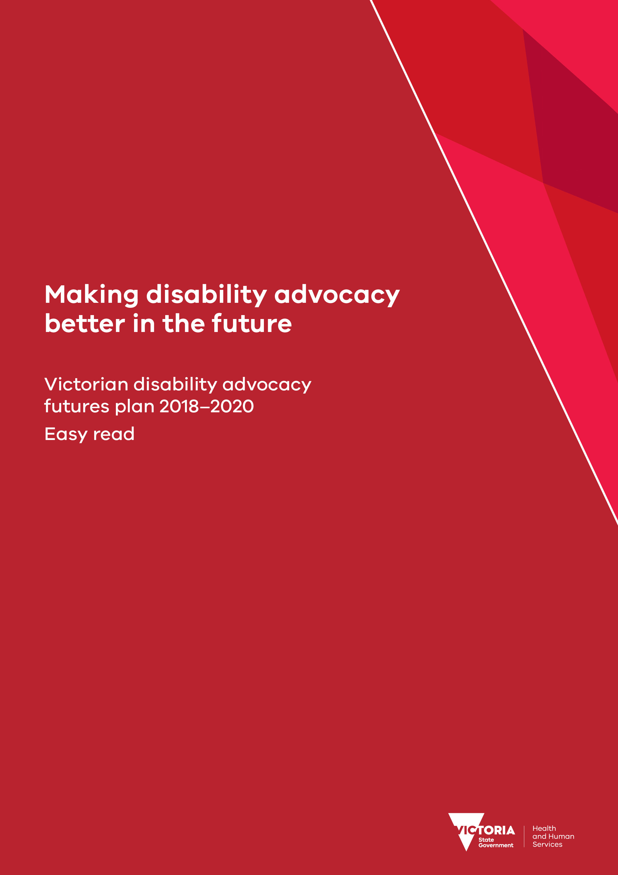

A message from the Minister
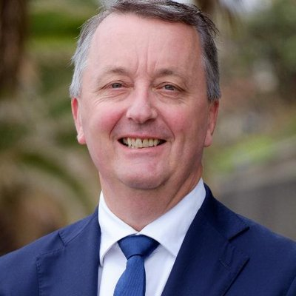 | My name is Martin Foley.  I am a member of Parliament.
I am the Minister in charge of:
- housing
- disability
- ageing.
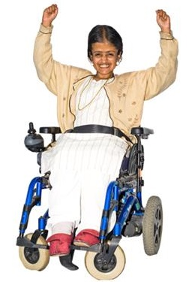 | I believe disability advocacy and self advocacy are really important.
 | Advocacy and self advocacy can help people with disability to have their say about things that are important to them.
 | This book is an easy read summary of the ‘Victorian disability advocacy futures plan 2018-2020’.
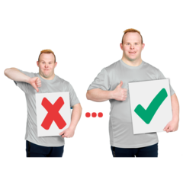 | In this book we will tell you all the things we are going to do to make advocacy and self advocacy better.
 | Thank you to everyone who shared their ideas that helped make the book.
Martin Foley
Minister for Housing, Disability and Ageing

About this book
 | In this book we will call the Victorian disability advocacy futures plan ‘the plan’
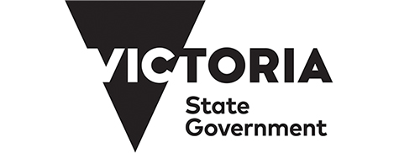 | In this book the word ‘we’ means the Victorian Government.
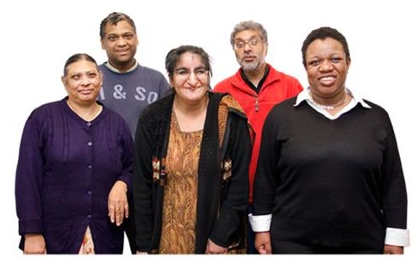 | In this book we say ‘disability advocacy groups’.  This includes people in self advocacy groups.
In this book hard words are in bold.
On pages 26, 27 and 28 we have a list of hard words and what they mean.

What is disability advocacy
Disability advocacy is about helping people with disability to get their rights.
Disability advocacy groups also help people with disability by doing self advocacy.
Self advocacy is:
- speaking up for your rights
- helping other people speak up for their rights.
Disability advocacy groups help people with disability by doing individual advocacy
Individual advocacy is:
- supporting people with disability about problems they are having.
Disability advocacy groups help people with disability by doing systemic advocacy.
Systemic advocacy is:
- making bigger changes by doing things like changing policy or the law.

How we made the plan
 | To make the plan we asked people how to make disability advocacy better.
 | We asked people lots of questions to get their ideas.
 | Lots of people and groups sent us their ideas.
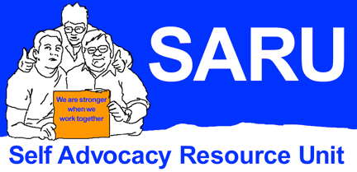 | The Self Advocacy Resource Unit spoke to self advocates to get their ideas.
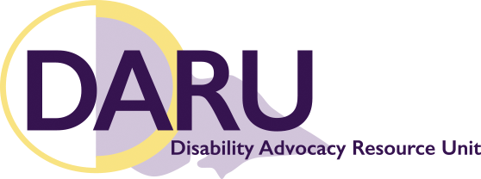 | The Disability Advocacy Resource Unit spoke to individual advocates to get their ideas.

Making advocacy better in the future
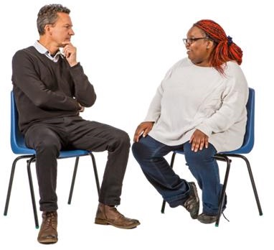 | When we made the plan we asked people to tell us why we need disability advocacy.
People gave us lots of ideas.
We used these ideas to make a vision statement.
A vision statement is what we want to see in the future.
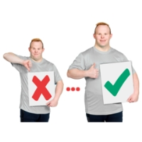 | Our vision statement says we want things to happen to make disability advocacy better in the future.
 | We want people with disability to be leaders in disability advocacy groups.
 | We want disability advocacy to include everyone.
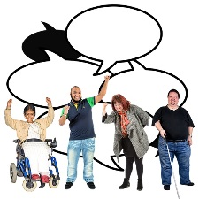 | We want disability advocacy to make sure people with disability:  - have rights
 | - have a good life.
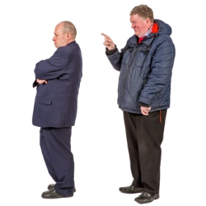 | We want disability advocacy groups to be independent.  Independent means having control of what you say and do.

More money for disability advocacy
More people need disability advocacy because of the NDIS.
This means disability advocacy groups are very busy.
We will give extra money to disability advocacy groups.
This plan will tell you how we are going to use the extra money.

How the plan works
The plan will start this year in 2018.
The plan will keep going in 2019.
The plan will finish on
31 December 2020.
The plan has 22 actions.
The actions include money we will give to disability advocacy groups.
 | The actions also include things we will do to help disability advocacy groups.
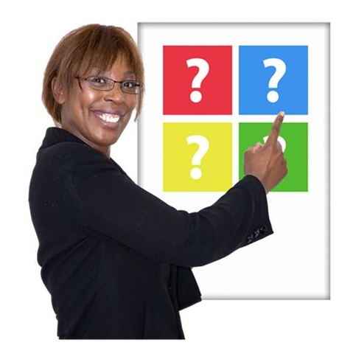 | The plan has 4 parts.  Each part is about a different thing.  Each part has actions.  Every action has a number.

Part 1 – Including everyone
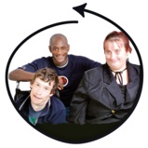 | Part 1 is about making sure that disability advocacy includes everyone.
Action 1.1
We will give money to disability advocacy groups to do projects.
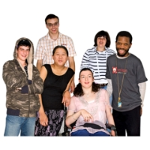 | Projects could help give different groups better advocacy including:
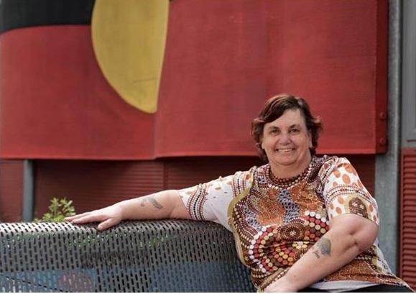 | - Aboriginal people
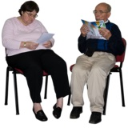 | - people who are hard to get to, for example people in homes for older people
 | - people who are lesbian, gay, bisexual or transgender
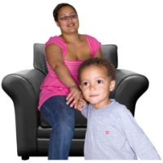 | - parents with disability.  This includes parents with intellectual disability.
Action 1.2
We will help disability advocacy groups tell other groups about their work.
This will help groups to learn from each other.
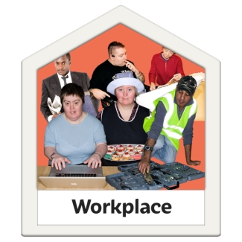 | Action 1.3  We will help disability advocacy groups give paid jobs to all people with disability.
We will help disability advocacy groups support people with disability to be leaders.
This is so people with disability can make important decisions about what advocacy groups do.
Action 1.4
We will do other things to support disability advocacy groups include everyone.
 | For example we will give people information about disability advocacy in different languages.

Part 2 – Working together
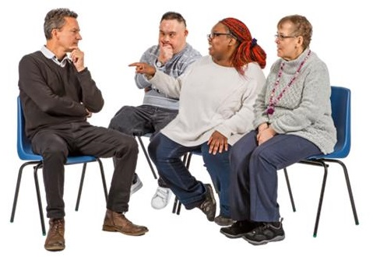 | Part 2 is about disability advocacy groups working together.  It is also about supporting different kinds of disability advocacy.
Action 2.1
We will give money to disability advocacy groups to do projects about:
 | - doing systemic advocacy to make big changes
 | - working with other groups.
Action 2.2
We will help disability advocacy groups tell people about important issues for people with disability.
Action 2.3
We will help disability advocacy groups find places to meet that are:
- free
- do not cost much money to use.
Action 2.4
We will tell government departments about
- advocacy projects which are trying to make bigger changes to policy or the law
 | - advocacy projects which are supporting people to speak up for their rights.

Part 3 – Advocacy when and where people need it
Part 3 of the plan is about giving disability advocacy to people:
- where they need it
- when they need it.
Action 3.1
We will give extra money to 24 groups supported by the Victorian Disability Advocacy Program.
This will be 25 per cent more money than they are getting now.
This will be for 2 years.
Action 3.2
We will give money to disability advocacy groups to do projects about:
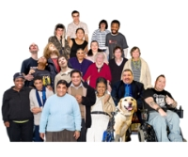 | - helping people get more advocacy  - telling more people about disability advocacy
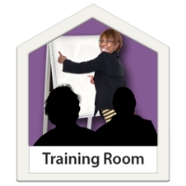 | - helping disability and self advocates to learn new things.
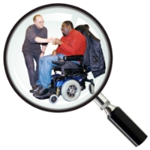 | Action 3.3  We will ask someone to do some research.
 | Research is when you find out more about something.
The research will try and find out:
- an easier way for people with disability and families to find disability advocacy groups
- how to give people looking for advocacy more information.
This could be about things like waiting lists.

Action 3.4
We are doing work to change attitudes about people with disability.
When we do this work we will:
- talk about the work disability advocacy groups do to change attitudes
- ask government departments to include disability advocacy groups in their work to change attitudes.
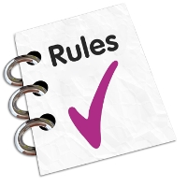 | Action 3.5  We will make sure that disability advocacy groups know important rules.
 | For example rules about people making complaints.
Action 3.6
We will we find out more about qualifications for disability advocates.
A qualification proves you can do something.
Action 3.7
We will work with disability advocacy groups to find better ways to help people when they call them.
This could be to:
- work out what people need from their group
- give people the help they need.

Part 4 – Planning for the future
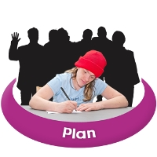 | Part 4 of the plan is about planning for the future.
Action 4.1
We will give money to disability advocacy groups to do projects about:
 | - helping disability advocacy groups plan for the future
 | - finding better ways to see if disability advocacy is working.
Action 4.2
We will ask someone to help us find better ways to measure:
- how well advocacy is working
- how advocacy makes a difference to people with disability.
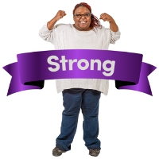 | Action 4.3  We will work with the Commonwealth Government to help them make sure advocacy is strong all over Australia.
Action 4.4
We will talk to disability advocacy groups about this plan.
We will ask them if the plan is working.
We will do this at forums and meetings.
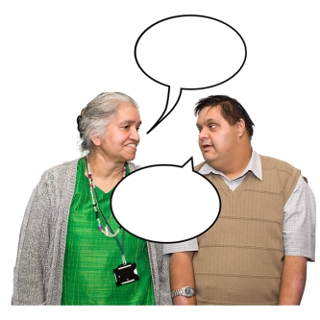 | Action 4.5  We will ask people what they think about this plan.  We will ask them what we should put in the next plan.
Action 4.6
We will make it easier for disability advocacy groups collect information about the work they do.
Action 4.7
We will make it easier for disability advocacy groups to give us information about the work that they do.

More information
You can get this book on the disability advocacy futures webpage.
<http://www.statedisabilityplan.vic.gov.au/advocacy-futures>
 | We can send you this book by in the post.
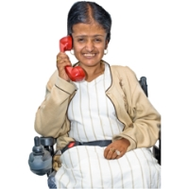 | You can phone the Office for Disability on:  1300 880 043.
You can email the Office for Disability
<disabilityadvocacy@dhhs.vic.gov.au>
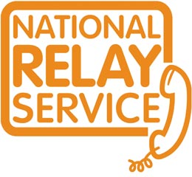 | You can phone using the National Relay Service on:  133 36 77.
You can phone using the Telephone Interpreter Service on:
131 450.

Hard words
Parliament is a group of people who have been voted to represent everyone.
Parliament make laws and decisions about how to spend public money.
Disability advocacy is about helping people with disability to get their rights.
Disability advocacy includes self advocacy, individual advocacy and systemic advocacy.
Self advocacy is:
- speaking up for your rights
- helping other people speak up for their rights.
Individual advocacy is:
- supporting people with disability about problems they are having.
Systemic Advocacy is:
• making bigger changes by doing things like changing policy or the law.
 | The Victorian Government is the government in change of Victoria.
 | A vision statement says what we want something to be like in the future.
 | Independent means having control of what you say and do.
A policy is a plan that says what the government is going to do about something.
Policy can also mean what the government thinks about something.
 | A law is a rule made by the government.
Research is when you find out more about something.
Research can mean learning from books. It can also mean talking to people to find out more.
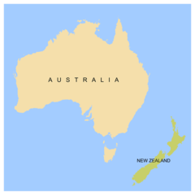 | Commonwealth Government is the government in charge of the whole of Australia.
 | A qualification proves you can do something.
To receive this publication in an accessible format phone
1300 880 043, using the National Relay Service 13 36 77 if required, or email the Office for Disability <disabilityadvocacy@dhhs.vic.gov.au>
Authorised and published by the Victorian Government, 1 Treasury Place, Melbourne.
© State of Victoria, Department of Health and Human Services, October 2018.
Except where otherwise indicated, the images in this publication show models and illustrative settings only, and do not necessarily depict actual services, facilities or recipients of services. This publication may contain images of deceased Aboriginal and Torres Strait Islander peoples.
Where the term ‘Aboriginal’ is used it refers to both Aboriginal and Torres Strait Islander people. Indigenous is retained when it is part of the title of a report, program or quotation.
ISBN 978-1-76069-692-4 (pdf/onlineMS word)
Available on the Advocacy futures webpage. <http://www.statedisabilityplan.vic.gov.au/advocacy-futures>
Pictures by Photosymbols, State of Victoria and the Commonwealth Government.

