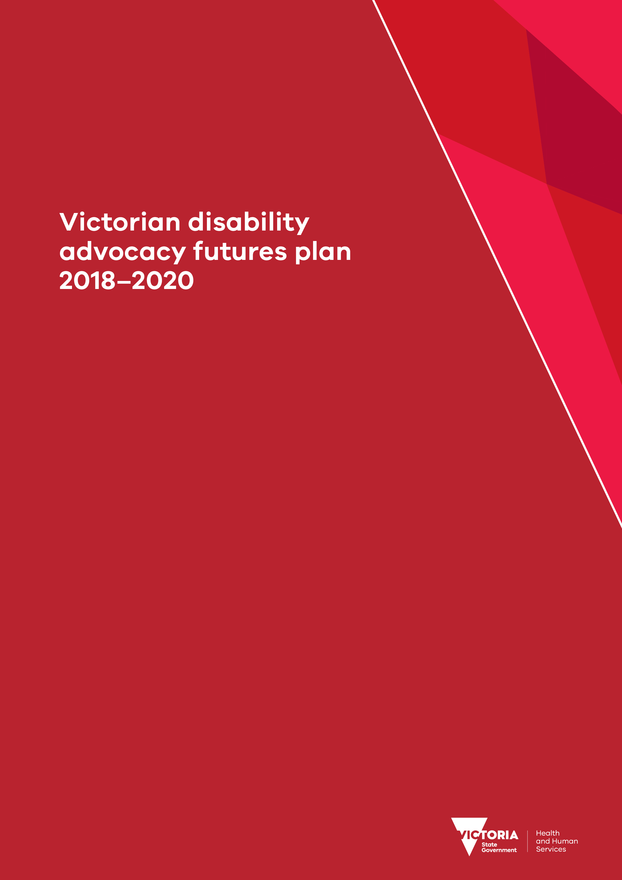

To receive this publication in an accessible format phone 1300 880 043, using the National Relay Service 13 36 77 if required, or email the Disability Advocacy team <disabilityadvocacy@dhhs.vic.gov.au>.
Authorised and published by the Victorian Government, 1 Treasury Place, Melbourne.
© State of Victoria, Department of Health and Human Services, October 2018.
Where the term ‘Aboriginal’ is used it refers to both Aboriginal and Torres Strait Islander people. Indigenous is retained when it is part of the title of a report, program or quotation.
ISBN 978-1-76069 Available on the Advocacy futures webpage <http://www.statedisabilityplan.vic.gov.au/advocacy-futures>

Minister’s foreword
For many years disability advocates and self advocates have been at the forefront of progressive thinking, making valuable contributions to improving the lives of people with disability. The Victorian Government recognises the importance of this work and will continue to invest in a strong, sustainable and independent disability advocacy sector.
On top of the $3 million in annual funding the Victorian Government provides to 24 organisations through the Victorian Disability Advocacy Program, by 30 June 2020, we will have invested more than $7.5 million in additional funding to strengthen disability advocacy in Victoria. This includes an additional $4.3 million over two years for the sector which will be provided over 2018–19 and 2019–20.
The Victorian disability advocacy futures plan 2018–2020 will inform how we use this additional funding over the next two years and guide longer-term reform of the Victorian Disability Advocacy Program beyond 2020.
The outcomes and actions in this plan are based on what people with disability, their families and advocates told us is important to make advocacy grow and get stronger in the future. I would like to thank everyone who contributed their ideas through the public consultation process.
Disability advocacy is a key priority of Absolutely everyone: state disability plan 2017–2020. The vision of Absolutely everyone is an inclusive Victoria that supports people with disability to live everyday satisfying lives. Disability advocacy is essential for achieving this vision during and long after our transition to the National Disability Insurance Scheme.
By working together we can continue to lead social change and uphold, promote and protect the human rights of people with disability.

Martin Foley
Minister for Housing, Disability and Ageing

Acknowledgement of Aboriginal Victoria
The Victorian Government proudly acknowledges Victoria’s Aboriginal communities and their rich culture and pays respect to their Elders past and present. We acknowledge Aboriginal people as Australia’s first peoples and as the Traditional Owners and custodians of the land and water on which we live, work and play. We recognise and value the ongoing contribution of Aboriginal people and communities to Victorian life and how this enriches our society more broadly. We embrace the spirit of self-determination and reconciliation, working towards equality of outcomes and ensuring an equitable voice.
Victorian Aboriginal communities and peoples are culturally diverse, with rich and varied heritages and histories both pre and post-invasion. The impacts of colonisation – while having devastating effects on the traditional life of Aboriginal Nations – have not diminished Aboriginal people’s connection to country, culture or community. Aboriginal Nations continue to strengthen and grow with the resurgence of language, lore and cultural knowledge. These rich and varied histories need to be understood and acknowledged by all Victorians, to truly understand the resilience and strength of previous generations, as well as the history of the fight for survival, justice and country that has taken place across Victoria and around Australia.
As we work together to ensure Victorian Aboriginal communities continue to thrive, the government acknowledges the invaluable contributions of generations of Aboriginal warriors that have come before us, who have fought tirelessly for the rights of their people and communities towards Aboriginal self-determination. We are now honoured to be part of that vision.

Contents
Minister’s foreword 3
Acknowledgement of Aboriginal Victoria 4
About the disability advocacy futures plan 7
Purpose of the plan 7
Who the plan is for 7
How we made the plan 7
Victorian Disability Advocacy Program 9
Who we fund through the program 9
Who we support through the program 9
Improving the program 11
Why disability advocacy is important 12
Disability advocacy and human rights 12
Disability advocacy and social inclusion 12
Disability advocacy and the NDIS 13
How the plan works 15
Our vision 15
Outcomes 15
Actions 16
Absolutely everyone: state disability plan 2017–2020 16
Principles 17
How the plan is funded 19
Existing funding 19
Additional funding in 2018–19 and 2019–20 20
Outcome 1: Inclusion – Disability advocacy is inclusive of everyone 21
Funding to the sector 22
Other support for the sector 23
Outcome 2: Connection – Disability advocacy is strong, connected and powerful 25
Funding to the sector 26
Other support for the sector 26
Outcome 3: Responsiveness – Disability advocacy is responsive and timely 28
Funding to the sector 28
Other support for the sector 30
Outcome 4: Sustainability – Disability advocacy grows into the future 31
Funding to the sector 32
Other support for the sector 32
More information 34

About the disability advocacy futures plan
‘Through advocacy education I have become empowered.’ (Disability advocacy futures discussion paper submission)

Purpose of the plan
The purpose of the Victorian disability advocacy futures plan 2018–2020 (the plan) is to ensure a successful disability and self advocacy sector now and into the future.
The plan will go until 31 December 2020 and will guide the Victorian Government to:
- make improvements to the Victorian Disability Advocacy Program
- decide how best to invest funding, including through the 2018–19 State Budget
  - respond to the community’s call for better access to advocacy
  - determine a longer -term approach to disability advocacy in Victoria from 2021.

Who the plan is for
The plan is for:
- people with disability so they can lead and access advocacy, including through self advocacy, paid leadership and employment opportunities
- families and carers so they can advocate alongside people with disability
- disability advocacy agencies so they can respond to demand, build connections, and create change
- other sectors so they can build effective and long-term partnerships with advocacy agencies
- the wider community so they know about advocacy, how to access it and its importance in upholding, protecting and promoting the rights of people with disability.

How we made the plan
Before we wrote this plan we wanted to find out what people thought would improve disability advocacy. We developed a discussion paper to outline our ideas. The discussion paper broke those ideas into three areas we called ‘action areas’:
- Action area 1: Delivering advocacy to more people with disability
- Action area 2: Providing more advocacy for diverse and isolated groups
- Action area 3: Helping the advocacy sector to support people with disability.
We asked people to respond to these action areas. We also wanted to know if there were other ways we should be supporting disability advocacy.

We asked for ideas by:
- sharing the discussion paper with disability advocacy agencies and other organisations committed to upholding the rights of people with disability
- having meetings with groups like the Victorian Disability Advisory Council
- promoting the discussion paper on social media and in newsletters
- funding the Disability Advocacy Resource Unit to seek feedback from 33 disability advocacy agencies by hosting two forums and interviews
- funding the Self Advocacy Resource Unit to host meetings with 13 self advocacy groups across Victoria, including 60 self advocates.
The discussion paper was available on the state disability plan website <http://www.statedisabilityplan.vic.gov.au/> and was available in easy read, Braille and audio versions. There was also a survey and a consultation workbook to help people give their feedback.
We received 37 responses from individuals with disability, advocacy groups and self advocacy groups and representative organisations. This is in addition to the group submissions received from the two resource units based on their consultations.
This plan is based on what people told us. We will continue to engage people with disability, their families and advocates as we deliver this plan. This is to make sure that we respond to new issues and opportunities over the next two years.
‘It’s like we’ve finally climbed that ladder, we don’t want to slide back down again.’ (Disability advocacy futures discussion paper submission)

Victorian Disability Advocacy Program

Who we fund through the program
The Victorian Government through the Office for Disability provides funding and support for disability advocacy through the Victorian Disability Advocacy Program. Every year we provide approximately $3 million to 24 disability advocacy agencies < https://providers.dhhs.vic.gov.au/disability-advocacy-and-self-help>.
The Victorian Disability Advocacy Program supports disability advocacy agencies to undertake three types of advocacy listed below.
- Self advocacy undertaken by someone with disability who speaks up and represents themselves. Support and training for self advocacy is available through community-based groups.
- Individual advocacy a one-on-one approach, undertaken by a professional advocate, relative, friend or volunteer, to prevent or address instances of unfair treatment or abuse.
- Systemic advocacy involves working for long-term social changes to ensure the collective rights and interests of people with disability are served through legislation, policies and practices.
These definitions are from the Disability Advocacy Resource Unit’s 2016 publication What is disability advocacy? We also recognise the role of other types of advocacy. For example, some disability advocacy agencies funded outside of the program provide legal representation and advice to help people navigate the court system.
Funding is provided to the Disability Advocacy Resource Unit and the Self Advocacy Resource Unit. The aim of the two resource units is to strengthen and support the disability advocacy and self advocacy sectors in Victoria.
The Disability Advocacy Resource Unit <http://www.daru.org.au/> supports the disability advocacy sector by developing networks, providing information, sourcing professional development opportunities for advocates and strengthening links with broader social policy advocacy.
The Self Advocacy Resource Unit <http://www.saru.net.au/> performs a wide range of roles to support self advocacy for people with an intellectual disability, people with an acquired brain injury and people with complex communication support needs. This includes networking with key stakeholders, creating and sharing resources, training, providing information on funding and running forums.

Who we support through the program
The program supports 2,000 people with disability and family members each year. A person can only be counted once each year, but they may use advocacy services a number of times for a number of different issues. This means that the ‘2,000 people’ figure does not provide a clear enough indication of the extent of advocacy services provided and its value to people with disability. This plan includes actions to improve the way we measure and evaluate the impact of disability advocacy.
Agencies currently collect a range of information through a quarterly data collection and reporting process. In July 2017, the Disability Advocacy Resource Unit published a report called Disability advocacy by the numbers <http://www.daru.org.au/disability-advocacy-by-the-numbers-statistics-from-july-2012-to-june-2016>. The report analysed statistics based on data collected between July 2012 and June 2016. Figure 1 includes key information from the report.

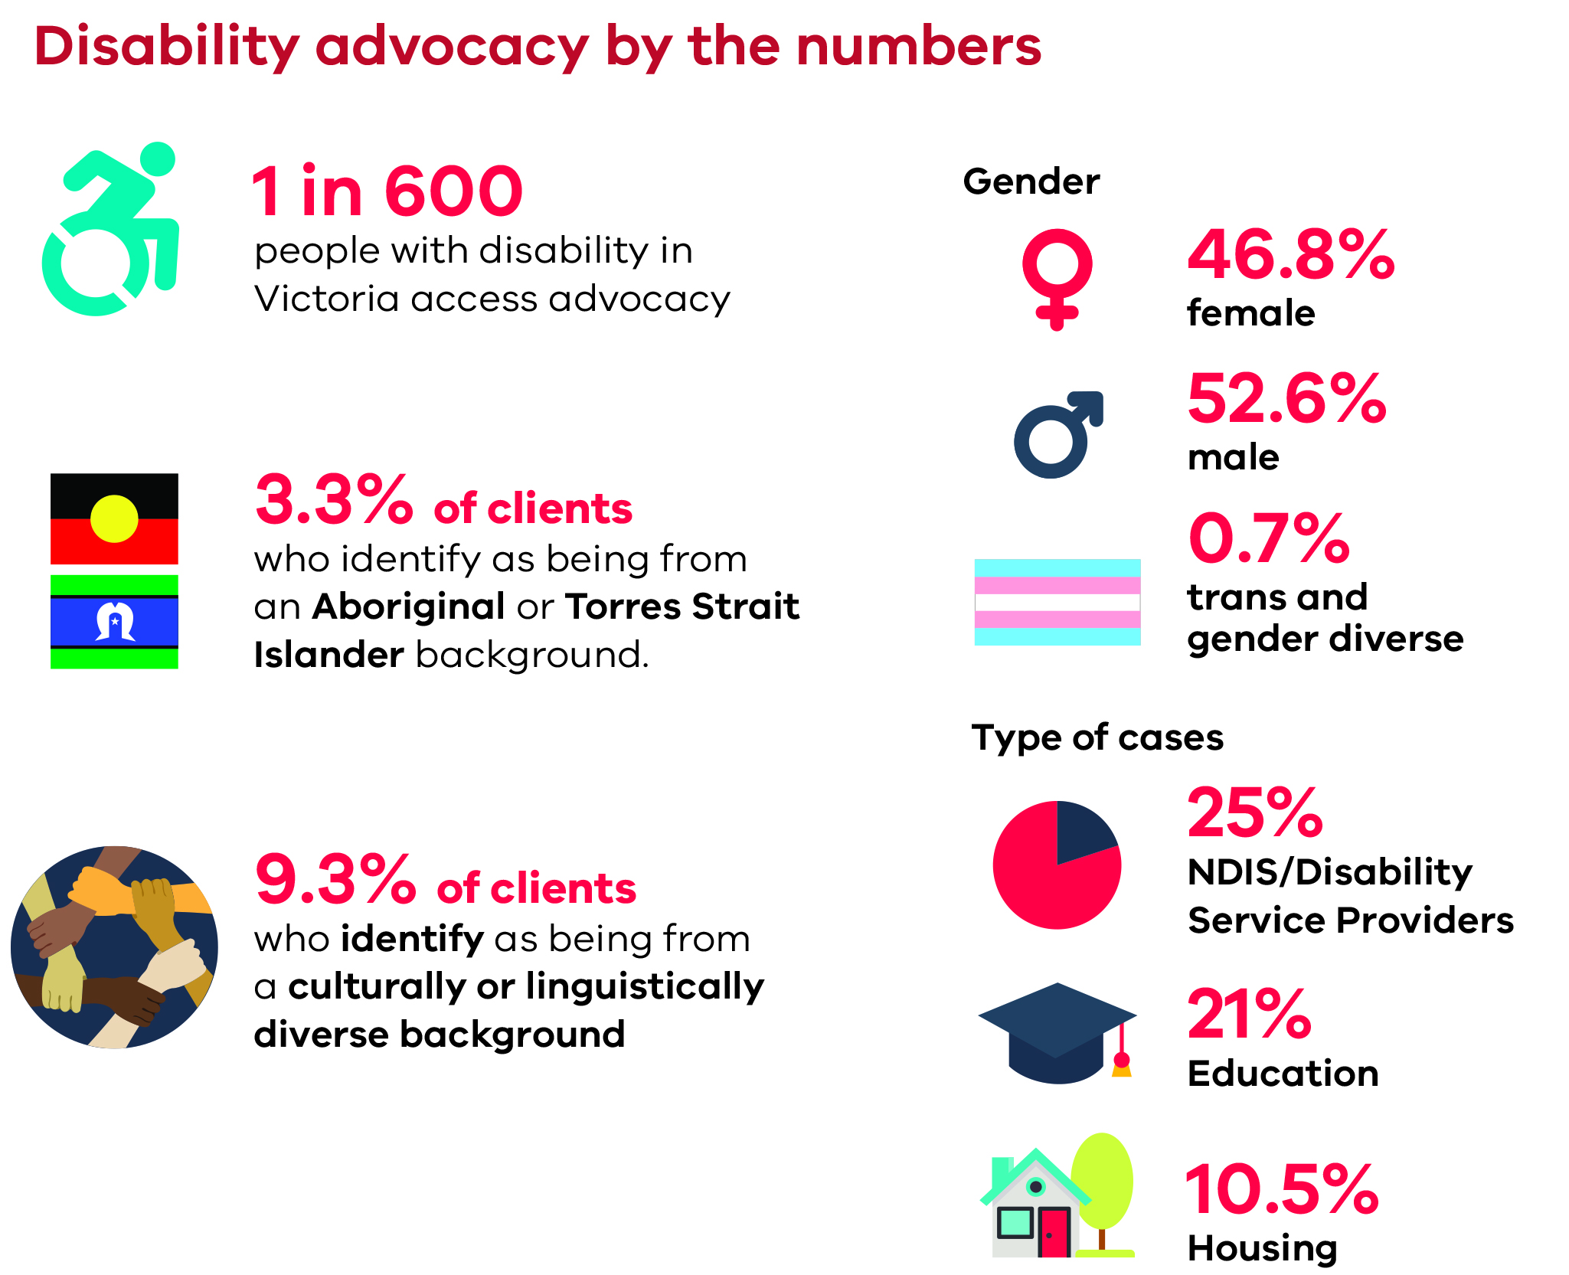

Improving the program
In 2016 the Victorian Government completed the Victorian Disability Advocacy Program Review. As part of the review, we consulted with the sector to find out about the program’s strengths and areas that needed improving. We also considered issues identified by the Parliamentary Inquiry into Abuse in Disability Services <https://www.parliament.vic.gov.au/fcdc/inquiries/inquiry/397> and the Victorian Ombudsman Investigation into Abuse in the Disability Sector <https://www. ombudsman.vic.gov.au/getattachment/c6499f78-0eec-4e4a-8e94-e4cd716a64f8>.
The Review of the Victorian Disability Advocacy Program <https://providers.dhhs.vic.
gov.au/disability-advocacy-and-self-help> identified Victoria as a national leader in self advocacy and sector support, provided through the Disability Advocacy Resource Unit and the Self Advocacy Resource Unit. It also found a resilient sector with other strengths, including a commitment to human rights, social justice and empowering people with disability. The areas for improvement included:
- increasing access, engagement and support for people with disability and their families
- building the capacity of the workforce
- improving how we measure performance and outcomes
- responding to increasing demand and gaps in service delivery
- providing different models of advocacy.
This plan builds on our existing efforts to respond to the review’s findings.

Why disability advocacy is important

Disability advocacy and human rights
Advocacy is a critical safeguard to prevent abuse and neglect and to uphold, promote and protect the rights of people with disability.
Every person is different and every person has human rights. Overall, people with disability continue to experience different life opportunities from people without disability. This experience of everyday discrimination is what people with disability have in common. We have a responsibility to address the widespread physical, social and cultural barriers that deny people with disability their human rights.
In Victoria, disability advocacy has a proud history of championing the human rights of people with disability. Self advocates and advocacy agencies have led the disability rights movement in building a fairer community for people with disability.
Upholding, promoting and protecting human rights and driving social change are the primary goals of advocacy. Human rights are vital in ensuring we recognise the value of every person regardless of where they live or work, how they look or think, or what they believe in.
There is an international framework to promote and protect human rights, established by the United Nations Universal Declaration of Human Rights.
Australia has also agreed to the United Nations Convention on the Rights of Persons with Disabilities <https://www.un.org/development/desa/disabilities/ convention-on-the-rights-of-persons-with-disabilities.html>. By ratifying the convention in 2008, Australia agreed to promote the equal and active participation of all people with disability.
The Victorian Government has roles and responsibilities across a range of policies and programs that affect people with disability, their families and carers. The main laws that help us to meet our responsibilities are:
- Charter of Human Rights and Responsibilities Act 2006 <https://www. humanrightscommission.vic.gov.au/human-rights/the-charter>
- Disability Act 2006 <https://services.dhhs.vic.gov.au/disability-act-2006>
- Equal Opportunity Act 2010 <https://www.humanrightscommission.vic.gov.au/the-law>

Disability advocacy and social inclusion
Research shows that people with disability can experience increased discrimination in every area of life. One way of thinking about this is through the social model of disability. The social model describes disability as being a result of a society that is not inclusive or accessible. Instead of changing the person with disability, the social model suggests that we need to change society to remove barriers that prevent people with disability living their lives the way they choose. Through the social model, disability advocacy seeks to change society to ensure all people with disability can be included in the social, civic and economic life of their community.
In September 2017, the Disability Advocacy Network Australia <http://www.dana.org.au> published A cost benefit analysis of Australian independent disability advocacy agencies report <https://www.dana.org.au/about/publications>. This report said that disability advocacy has improved the capacity of people with disability to manage their lives while reducing the use of government services such as police and hospitals. It found that disability advocacy improved the lives of many thousands of people with disability, which benefits the wider Australian community.
The community and other sectors also have a part to play in promoting the human rights of people with disability. The National Disability Insurance Scheme (NDIS) has helped make this responsibility clear. The community, business and government all have responsibilities for promoting the human rights and inclusion of people with disability. This makes the role of independent disability advocacy, which works across all sectors, more important than ever.
This plan is vital to achieving the Victorian Government’s vision of an inclusive Victoria through Absolutely everyone: state disability plan 2017–2020 <http://www.statedisabilityplan.vic.gov.au/>. This plan also supports and works alongside other policies focused on reducing discrimination and increasing social inclusion.

Disability advocacy and the NDIS
The NDIS <https://www.ndis.gov.au/about-us/our-sites/VIC.html> is the biggest national social reform since the introduction of Medicare, giving greater independence, choice and flexibility to people with disability and their carers and families.
Feedback through the consultation on the discussion paper told us that advocacy is critical to support people with disability and their families to access and navigate the NDIS. It told us that demand for disability advocacy is increasing because of the NDIS.
In October 2017 the Productivity Commission NDIS costs report <https://www. pc.gov.au/inquiries/completed/ndis-costs#report> recommended that governments continue to fund advocacy outside of the NDIS. They found that reducing or removing advocacy imposes costs on the wellbeing of people with disability, their families and the community.
It is important that the rights of people with disability under existing Victorian laws are not reduced while we transition to the scheme. The Victorian Government is leading the country in ensuring safe and quality services. We want to make sure we get the scheme right. This means making sure it is in keeping with its agreed values of:
- quality
- safeguards
- standards
  - clear and enforceable rights for all people.
An important part of ensuring that the scheme keeps to these values is ensuring that people with disability have access to good disability advocacy support.
A national approach to independent disability advocacy is needed to ensure the success of the NDIS.
In 2017 the Australian Government published the Review of the National Disability Advocacy Program consultation report <https://engage.dss.gov.au/national-disability-advocacy-program/review-of-the-national-advocacy-program-consultation-report/>. This review also found a need to improve access to disability advocacy support across Australia. The issues it highlighted were:
- availability of advocacy support in all areas, including access for people with disability in rural, regional and remote locations
- access for people who are socially isolated
- access for Aboriginal and culturally diverse communities
  - coordination of systemic issues, working with the NDIS and access to justice.
This plan will support the Victorian Government to lead the way and influence better advocacy for people with disability across Australia.

How the plan works
Figure 2 provides an overview of the plan and further details on the areas covered in this section.

Our vision
We asked for feedback on an objective for the Victorian Disability Advocacy Program. People told us that the objective needed to reflect:
- a stronger vision for disability advocacy in Victoria
- the voice and ownership of people with disability
- that advocacy is a shared responsibility – not just for organisations funded under the Victorian Disability Advocacy Program.
We have developed a new vision for the Victorian disability advocacy futures plan 2018–2020:
A thriving independent disability advocacy and self advocacy sector led by and for people with disability that reflects their diverse voices and takes action to uphold and promote their rights, wellbeing and interests.
People also told us that the vision needs to reflect:
- the role of families and carers in supporting disability advocacy
- that people with disability need resources and support to lead advocacy.
We recognise that these things are important to achieve our vision. However, we have maintained the focus on leadership and ownership by people with disability. This is to reinforce the principle of ‘nothing about us without us’. This also supports the principle of choice and control as part of our transition to the NDIS.
The plan includes specific outcomes to support leadership of people with disability and the role of families and carers.

Outcomes
The plan has four outcome areas. These demonstrate the progress we want to make towards our vision. The four outcome areas are:
Inclusion – Disability advocacy is inclusive of everyone
Connection – Disability advocacy is strong, connected, and powerful
Responsiveness – Disability advocacy is responsive and timely
Sustainability – Disability advocacy grows into the future.
These outcomes are based on what people told us is important. We have developed indicators that we will use to measure the success of the plan.

Actions
The plan includes 22 actions under each of the four outcome areas. These will help us to achieve our aims.
There are two categories of action under each outcome area:
- funding to the sector – initiatives for which we can fund disability advocacy agencies and other organisations to achieve our outcomes.
- other support for the sector –actions the Victorian Government will take to support the sector to achieve our outcomes.
Actions include funding, partnerships and program improvements to:
- build the capacity of organisations funded under the Victorian Disability Advocacy Program to better support people with disability and their families
- increase advocacy by and for diverse and hard- to-reach groups, for example Aboriginal people, people who identify as LGBTI, women and people from culturally and linguistically diverse communities
- increase paid leadership and employment opportunities for people with disability
- strengthen systemic advocacy in key areas such as education and the NDIS
- grow Victoria’s self advocacy sector including in rural and regional areas
- promote advocacy to people with disability, families and the broader community
- support the sector to plan for the future and measure the impact of what they do
- enhance the way we measure and evaluate disability advocacy outcomes
- plan for future changes including a simpler and more transparent intake process.

Absolutely everyone: state disability plan 2017–2020
Absolutely everyone sets the Victorian Government’s vision for an inclusive Victoria. One of the key priorities of Absolutely everyone is to strengthen the disability advocacy sector.
Through this plan we will look at ways to demonstrate how disability advocacy is contributing to the vision, pillars and outcomes of Absolutely everyone. <http://www.statedisabilityplan.vic.gov.au/ >.

Principles
The plan is guided by the following principles :
Led by people with disability: Nothing about us without us
  - people with disability practice genuine self-determination.
Committed to upholding human rights
  - advocacy is committed to ensuring all people have equal rights.
Courageous
  - advocacy speaks up and takes action to challenge discrimination and disadvantage.
Independent
  - advocacy acts freely without concern or conflict.
Professional
  - advocacy avoids conflicts of interest and provides timely service and equity of access.
Responsive
- advocacy is tailored to individual needs.
Figure 2: Overview of the Victorian disability advocacy futures plan 2018–2020
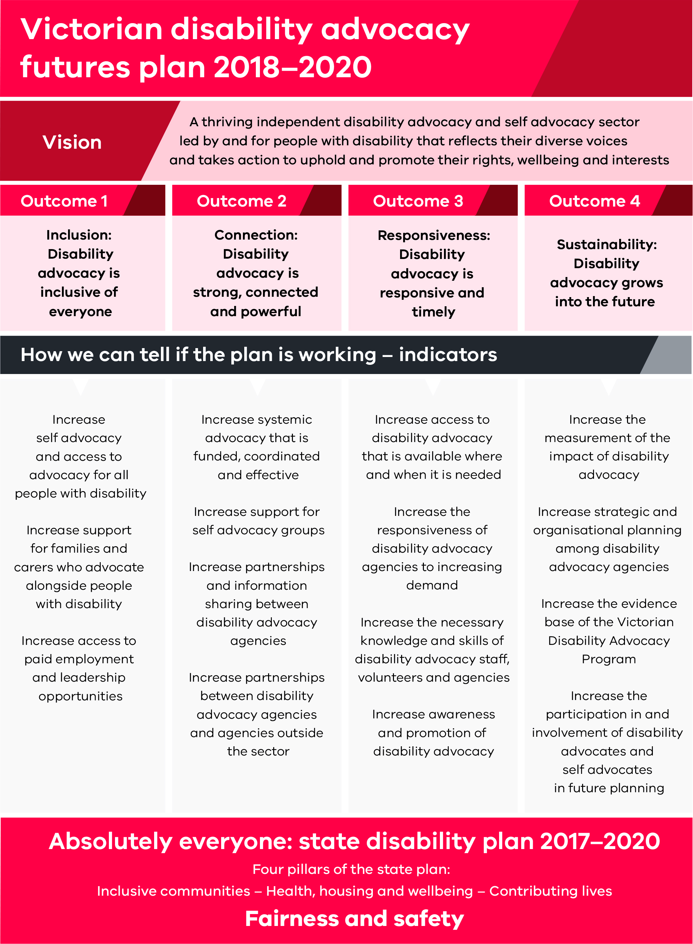

How the plan is funded

Existing funding

Ongoing Victorian Disability Advocacy Program funding
The Victorian Disability Advocacy Program provides $3 million in annual recurrent funding to 24 organisations. This plan and its vision provide a framework for funded organisations to deliver effective advocacy to people with disability and their families.

2016–17 Disability Advocacy Innovation Fund
In June 2017, in response to the Victorian Disability Advocacy Program Review, the Minister for Housing, Disability and Ageing Martin Foley MP, announced a fixed-term investment of $1.5 million. This investment gave an initial boost to the sector through the Disability Advocacy Innovation Fund <https://providers.dhhs.vic.gov.au/disability-advocacy-and-self-help>.
The Disability Advocacy Innovation Fund supported 21 advocacy initiatives with a strong focus on self advocacy, place-based advocacy initiatives and advocacy in rural and regional areas. These initiatives provided more support to Aboriginal communities, culturally diverse communities and people who identify as lesbian, gay, bisexual, trans, gender diverse or intersex (LGBTI).
We will summarise the findings and case studies from these initiatives to support innovation, share good practice and raise community awareness of advocacy. These will be promoted on our website in late 2018.

2017–18 State Budget
The Disability Advocacy Sector Capacity Building Fund <https://providers.dhhs.vic.gov.au/disability-advocacy-and-self-help> provides additional short-term funding of $1.57 million to the sector. Through 15 funded projects, targeted assistance is being provided to organisations supporting people with disability, including people with an acquired brain injury, women with disability, LGBTI community members, people in isolated areas and people from culturally diverse backgrounds.
Aboriginal communities will have better access to advocacy with $200,000 provided to expand existing initiatives. The Rights Information and Advocacy Centre has received $140,000 and Grampians Disability Advocacy Association has received $60,000 to work in partnership with local Aboriginal groups.
These initiatives are supporting early action as part of this plan and can provide a foundation to build on through additional funding in 2018–19 and 2019–20.

Additional funding in 2018–19 and 2019–20
Fixed-term funding over the next two years will help delivery of the plan’s outcomes. Table 1 provides further information.
Funding can be summarised as follows:
- a 25 per cent increase in funding for each of the 24 agencies supported through the Victorian Disability Advocacy Program ($1.55 million over two years)
- $2.15 million over two years through the Victorian Disability Advocacy Futures Grants Program
- funding to support delivery and evaluation of the plan, and to make improvements to the Victorian Disability Advocacy Program ($0.6 million over two years)
Table 1: Additional funding in 2018–19 and 2019–20
Funding | Further information
A 25 per cent increase in funding for each of the 24 agencies supported through the Victorian Disability Advocacy Program ($1.55 million over two years). | - Additional funding will be fixed-term and cover the period from 1 July 2018 to 30 June 2020.  - Funding will focus on responding to increased demand and can support delivery of outcomes in this plan.  - Funding will be monitored and evaluated (this will also support an evidence base for funding beyond 2020.)
$2.15 million over two years through the Victorian Disability Advocacy Futures Grants Program. | - Funding will be divided into four streams aligned to the outcomes of this plan.  - Organisations outside of the program can apply, partnerships will be strongly encouraged.  - Criteria will be aligned to the principles of this plan.  - Funded projects can be delivered over two financial years (2018–19 and 2019–20).  - Grants will be for between $10,000 and $150,000.  - Grant applications will open in early 2019.
Funding to support delivery and evaluation of the plan, and to make improvements to the Victorian Disability Advocacy Program ($0.6 million over two years). | - Dedicated staff member within the Office for Disability to support the delivery of the plan and improvements to the Victorian Disability Advocacy Program.  - Funding for external expertise to help evaluate the plan and to help plan for future improvements from 2021.

Outcome 1: Inclusion – Disability advocacy is inclusive of everyone
‘We must recognise that certain population groups experience multiple forms of disadvantage. Intersectionality stresses the importance of recognising the intersecting and overlapping nature of disadvantage, which can be related to factors such as disability, gender, race, geography and sexuality.’ (Disability advocacy futures discussion paper submission)
During the consultation about this plan you told us that:
- Disability advocacy needs to be more inclusive of people from hard-to-reach and diverse backgrounds.
- Because of their unique identities and circumstances some groups of people with disability experience more disadvantage than others.
- Advocacy services need to lead by example and ensure that their own organisations are inclusive of all people.
- It is very important that people with disability are employed in advocacy agencies and that we work towards ensuring that advocacy is led by people with disability.
This outcome area includes actions to support disability advocacy agencies to represent the diverse voices and needs of people with disability.
The indicators we will use to check if the actions from the plan are working are:
- increase self advocacy and access to advocacy for all people with disability
- increase support for families and carers who advocate alongside people with disability
- increase access to paid employment and leadership opportunities.

Funding to the sector

Action 1.1
We will provide funding through the Victorian Disability Advocacy Futures Grants Program which will be established in early 2019. The program will include an ‘Inclusion’ funding stream to help deliver actions under this outcome. Below are some examples of initiatives and priority areas that could respond to people’s diverse needs.
Priority | Examples of initiatives
Aboriginal people with disability can lead and access advocacy. | - Building partnerships with Elders and Aboriginal Community Controlled Organisations (ACCOs) to promote a self-determined approach to disability advocacy – for example through cross-cultural awareness and co-locating advocates in ACCOs
Children and young people with disability can lead and access advocacy. | - Improving advocacy for children and young people with disability – this could be in a range of settings including schools, out of home care, child protection and youth justice
Families and carers are supported to advocate for people with disability. | - Providing training and resources for families to support them to self-advocate or advocate alongside their family member
Hard-to-reach or isolated people with disability can lead and access advocacy. | - Using online technology, social media and community influencers to engage people with disability who are hard-to-reach, bedridden or housebound  - Improving advocacy in isolated settings – for example, young people with disability in aged care  - Providing advocacy to other groups who are hard-to-reach or isolated
LGBTI people with disability can lead and access advocacy. | - Building partnerships and alliances that reduce systemic barriers for people who identify as LGBTI  - Supporting people who identify as LGBTI to access and lead advocacy and self advocacy initiatives
Parents with disability can lead and access advocacy. | - Building the capacity of advocacy organisations to support parents with disability involved with, or at risk of being involved with the child protection system  - Building the capacity of parents with disability to advocate for themselves and their family
Refugees, newly arrived and established migrants with disability can lead and access advocacy. | - Building partnerships with refugee and settlement agencies and community leaders  - Building the capacity of culturally diverse people with disability and their families to advocate for themselves
Women with disability can lead and access advocacy. | - Building partnerships to improve the responsiveness of family safety, women’s health and other relevant organisations  - Building the capacity of women with disability to advocate for themselves
People with disability can access paid employment and leadership opportunities. | - Building partnerships with relevant organisations to provide training and resources for staff and board members  - Paid internships for people with disability including students to gain work experience in the sector  - Leadership programs for young and emerging advocates

Other support for the sector

Action 1.2
We will support advocacy agencies delivering initiatives for hard-to-reach and diverse groups to share their good practice with other sectors, including:
- children, youth and family services
- Aboriginal Community Controlled Organisations and networks
- migrant resource centres and settlement services
- family safety organisations and women’s health organisations
- relevant government departments

Action 1.3
We will identify opportunities to support disability advocacy agencies to employ people with disability through Absolutely everyone and Every opportunity: Victorian economic participation plan for people with disability 2018–2020.
We will continue to work with partner organisations to deliver leadership programs for people with disability, including sector capacity building to ensure representation on committees and boards.

Action 1.4
We will:
- collect better information and data on the numbers of people with disability from diverse groups accessing advocacy, people’s experiences and outcomes
- update program guidelines to reinforce the importance of increasing the representation of people with disability in paid and unpaid positions, governance and decision-making processes
- work with partner organisations to provide information about the program in community languages and promote this to different sectors and relevant government departments
- publish and promote case studies of initiatives supporting disability advocacy for everyone.
‘One of the best ways to help the advocacy sector support people with a disability is through the creation of a diverse workforce that includes people with a disability.’ (Disability advocacy futures discussion paper submission)

Outcome 2: Connection – Disability advocacy is strong, connected and powerful
‘Eleven years ago there were only three of us and we started off with nothing. We have come a long way but we are still getting there.’
Disability advocacy futures discussion paper submission
During the consultation about this plan you told us that:
- many people with disability are being discriminated against and that more people need to know about advocacy
- you want to see more funding for systemic advocacy that is co-ordinated, effective and well-funded
- to make advocacy more effective we all need to work together
- working together can be hard because there isn’t always time to build relationships and communication across the sector can be challenging
- to build relationships we need the right resources, support and equipment.
This outcome area includes actions to support different types of advocacy, increase the reach of advocacy and support partnerships within and outside of the sector.
The indicators we will use to check if the actions from the plan are working are:
- increase systemic advocacy that is funded, co-ordinated and effective
- increase support for self advocacy groups
- increase partnerships and information sharing between disability advocacy agencies
- increase partnerships between disability advocacy agencies and agencies outside the sector.

Funding to the sector

Action 2.1
We will provide funding through the Victorian Disability Advocacy Futures Grants Program which will be established in early 2019. The program will include a ‘Connection’ funding stream to help deliver actions under this area. Below are some examples of initiatives and priority areas which could create a strong, connected and powerful disability advocacy sector.
Priority | Examples of initiatives
Systemic advocacy is funded, co-ordinated and effective. | Projects to achieve systemic change in particular areas, for example:  - education  - NDIS  - housing and accommodation  - access to and interaction with the justice system  - health  - transport
Self advocacy groups have the support they need to grow. | - Funding self advocacy groups in rural and regional areas and groups targeting diverse and hard-to- reach groups.  - Access to professional development for self advocates – for example about attending meetings and being part of advocacy campaigns
Disability advocacy agencies can work together. | - Supporting collaboration and information sharing – for example, through communities of practice or job-sharing and secondments
Disability advocacy agencies can build strong connections outside of their sector. | - Building partnerships with other sectors working on particular issues – for example, with mental health advocates or community legal centres

Other support for the sector

Action 2.2
We will provide opportunities for disability advocacy agencies and self advocates to share systemic advocacy initiatives or to discuss important issues for people with disability. This can be with each other or with relevant government departments.

Action 2.3
We will work in partnership with local government and other organisations to develop a list of free or low-cost community venues. This will provide self advocates and disability advocacy agencies with local meeting places and support them to build partnerships.

Action 2.4
We will:
- publish and promote case studies of systemic and self advocacy initiatives
- share information on systemic advocacy initiatives with relevant departments to influence outcomes through Absolutely everyone and related initiatives.
‘I’ve got my licence; I am working and I am doing a TAFE course to become a disability support worker all because of self advocacy.’ (Disability advocacy futures discussion paper submission)

Outcome 3: Responsiveness – Disability advocacy is responsive and timely
‘I had my NDIS planning meeting. The planner wouldn’t listen to me, and my plan came back with nothing I asked for. I called on my advocate for help with this. She made them have a new meeting and then I got more things. Advocacy is so important to me because lots of people like the NDIS have a louder voice than me.’ (Disability advocacy futures discussion paper submission)
During the consultation about this plan you told us that:
- demand for advocacy is increasing
- your organisations have waiting lists for individual advocacy, many for the first time
- your organisations are expanding quickly but need to develop new policies in order to keep up
- new and established advocates need training in a range of areas to ensure they are able to do their jobs well
- there needs to be accountability for how advocacy funding is used
- we need a simpler and more transparent intake process for people with disability and their families.
This outcome area includes actions to increase the capacity of disability advocacy agencies and raise the profile of disability advocacy.
The indicators we will use to check if the actions from the plan are working are:
- increase access to disability advocacy that is available where and when it is needed
- increase responsiveness of disability advocacy agencies to increasing demand
- increase necessary knowledge and skills of disability advocacy staff, volunteers and agencies
- increase awareness and promotion of disability advocacy.

Funding to the sector

Action 3.1
We will provide a 25 per cent funding increase to 24 agencies supported through the Victorian Disability Advocacy Program. This will help deliver the following outcomes:
- people can access disability when and where they need it
- disability advocacy organisations can respond to increasing demand.
Examples of how disability advocacy agencies can use this extra funding include:
- employing additional staff and support workers
- purchasing minor works and equipment including computers and office furniture
- contributing to the cost of travel to rural and regional areas
- supporting other outcomes under the plan – for example to increase access to paid employment and leadership opportunities.
The Disability Advocacy Resource Unit and Self Advocacy Resource Unit can use this funding to help disability and self advocates deliver the plan’s outcomes.
Organisations will need to prepare project and evaluation plans. This will help ensure that the additional funding is supporting the outcomes of this plan. It will also help us build an evidence base for funding from 2021.

Action 3.2
We will provide funding through the Victorian Disability Advocacy Futures Grants Program which will be established in early 2019. The program will include a ‘Responsiveness’ funding stream to help deliver actions under this outcome area. Below are some examples of initiatives and priority areas that could support a more responsive and timely sector.
Priority | Examples of initiatives
People can access disability advocacy when and where they need it. | - Supporting partnerships and networks between rural, regional and state-wide disability advocacy agencies  - Technology to engage people with disability and families in rural and regional areas – for example, through video conferencing and Skype
Disability advocacy staff, volunteers and agencies have the knowledge and skills they need. | Access to professional development for advocates to increase their understanding of relevant matters including:  - family violence  - the legal system  - self advocacy groups  - working with mainstream media
More people know about advocacy. | - Campaigns and other initiatives to promote advocacy to people with disability, families and the broader community

Other support for the sector

Action 3.3
We will commission research to help develop a simpler and more transparent intake process for people with disability and their families from 2021.

Action 3.4
We will promote the role and importance of disability advocacy as part of broader work to change attitudes. This will be part of key priority 1of Absolutely everyone ‘community attitudes’. This will include working with other parts of government to include disability advocates and self advocates in relevant campaigns and programs.

Action 3.5
We will ensure program guidelines support advocacy agencies to provide an accessible and responsive service. We will provide program guidelines that include clear information on existing requirements for disability advocacy agencies as part of funding and service agreements. We will help advocacy agencies understand and implement these guidelines.

Action 3.6
We will work with partner organisations to investigate the resources and value of developing a nationally accredited qualification in disability advocacy.

Action 3.7
We will work with partner organisations to provide a more consistent and streamlined intake process for advocates.

Outcome 4: Sustainability – Disability advocacy grows into the future
‘Measuring advocacy based on the number of clients who received support in any given financial year does not take into account the complex nature of many client issues, the amount of time spent on them relative to each other, and the resources required to support the clients through the advocacy process.’ Disability advocacy futures discussion paper submission
During the consultation about this plan you told us that:
- the way we measure the effectiveness of advocacy is not working and does not capture the full range of work
- we need to develop a new, simple way to show how well advocacy works
- we need to ensure advocacy is funded properly in the future
- one off project funding makes long-term planning difficult
- advocacy agencies need support and resources to plan for the future.
This outcome area includes actions to ensure disability advocacy continues to grow and has a plan for the future.
The indicators we will use to check if the actions from the plan are working are:
- increase the measurement of the impact of disability advocacy
- increase strategic and organisational planning of disability advocacy agencies
- improve the evidence base of the Victorian Disability Advocacy Program
- increase participation and involvement of disability advocates and self advocates in future planning.

Funding to the sector

Action 4.1
We will provide funding through the Victorian Disability Advocacy Futures Grants Program which will be established in early 2019. The program will include a ‘Sustainability’ funding stream to help deliver actions under this outcome area. Below are some examples of initiatives and priority areas that could support disability advocacy to grow into the future.
Priority | Examples of initiatives
Disability advocacy agencies can measure the impact of what they do. | - Purchasing of client management systems and other technology
Disability advocacy agencies can plan for the future. | - Strategic and organisational planning  - External advice and professional development, for example regarding good governance and human resources management

Other support for the sector

Action 4.2
We will seek external advice to help us to measure and evaluate the outcomes of this plan and the Victorian Disability Advocacy Program.
We will do this in consultation with disability advocates, self advocates and other key stakeholders, including the Victorian Disability Advisory Council and the National Disability Advocacy Program.
This work will strike a balance between providing the evidence we need to demonstrate the impact of disability advocacy and minimising reporting requirements for disability advocacy agencies.

Action 4.3
We will continue to work with the Commonwealth Government and other states and territories in the context of the National Disability Advocacy Program.
This will be to advocate for a longer-term approach to the funding and administration of disability advocacy across Australia.
It will also be to ensure that reforms to the Victorian and national programs complement each other and minimise red tape for advocacy agencies.

Action 4.4
We will continue to update disability advocacy agencies and self advocates about changes to the Victorian Disability Advocacy Program and progress against this plan including through:
- presentations at Disability Advocacy Resource Unit forums
- presentations at meetings of the Victorian Self Advocacy Network
- meetings with individual disability advocacy agencies.

Action 4.5
We will consult people with disability, their families and their advocates on a longer- term plan and funding. This will help us develop another plan for the future of disability advocacy from 2021. We will do this from 1 July 2020 so people have enough time to provide their feedback. We will use what we have learnt from this plan.

Action 4.6
We will provide tools for disability advocacy agencies to support them to collect better information to measure and evaluate advocacy outcomes.

Action 4.7
We will continue to identify ways to improve and streamline data collection for the Victorian Disability Advocacy Program.

More information
You can get a copy of this plan on the state disability plan website <http://www.statedisabilityplan.vic.gov.au/advocacy-futures>
You can email the Office for Disability <disabilityadvocacy@dhhs.vic.gov.au>
You can phone the Office for Disability on 1300 880 043 or 9096 7246 (you can use the National Relay Service 13 36 77 if required).

Appendix 1: Text-equivalent descriptions of graphics used in this document

Figure 1: Disability advocacy by the numbers
- 1 in 600 people with disability in Victoria access advocacy
- 3.3% of clients who identify as being from an Aboriginal and Torres Strait Islander background
- 9.3% of clients who identify as being from a culturally or linguistically diverse background
- Gender: 46.8% female, 52.6% male, 0.7% trans and gender diverse
- Types of cases: 25% NDIS/Disability service providers, 21% Education,10.5% Housing

Figure 2: Overview of the Victorian disability advocacy futures plan 2018–2020

Victorian disability advocacy futures plan 2018–2020

Vision
A thriving independent disability advocacy and self advocacy sector led by and for people with disability that reflects their diverse voices and takes action to uphold and promote their rights, wellbeing and interests

Outcomes
Outcome 1 – Inclusion: Disability advocacy is inclusive of everyone
Outcome 2 – Connection: Disability advocacy is strong, connected and powerful
Outcome 3 – Responsiveness: Disability is responsive and timely
Outcome 4 – Sustainability: Disability advocacy grows into the future

How we can tell if the plan is working – indicators

Outcome 1
- Increase self advocacy and access to advocacy for all people with disability
- Increase support for families and carers who advocate alongside people with disability
- Increase access to paid employment and leadership opportunities

Outcome 2
- Increase systemic advocacy that is funded, coordinated and effective
- Increase support for self advocacy groups
- Increase partnerships and information sharing between disability advocacy agencies
- Increase partnerships between disability advocacy agencies and agencies outside the sector

Outcome 3
- Increase access to disability advocacy that is available where and when it is needed
- Increase the responsiveness of disability advocacy agencies to increasing demand
- Increase the necessary knowledge and skills of disability advocacy staff, volunteers and agencies
- Increase awareness and promotion of disability advocacy

Outcome 4
- Increase the measurement of the impact of disability advocacy
- Increase strategic and organisational planning among disability advocacy agencies
- Increase the evidence base of the Victorian Disability Advocacy Program
- Increase the participation in and involvement of disability advocates and self-advocates in future planning

Four pillars of the Absolutely everyone: state disability plan 2017–2020
- Inclusive communities
- Health, housing and wellbeing
- Contributing lives
- Fairness and safety

In this plan, the term ‘disability advocacy’ includes self advocacy. ‘Disability advocacy agencies’ include self advocacy groups.

